**Case Study: Banking System**

**Task 1: Database design**

1.Create the database named "HMBank"

Query: create database HMBank;

2.Define the schema for the Customers, Accounts, and Transactions tables based on the

provided schema.

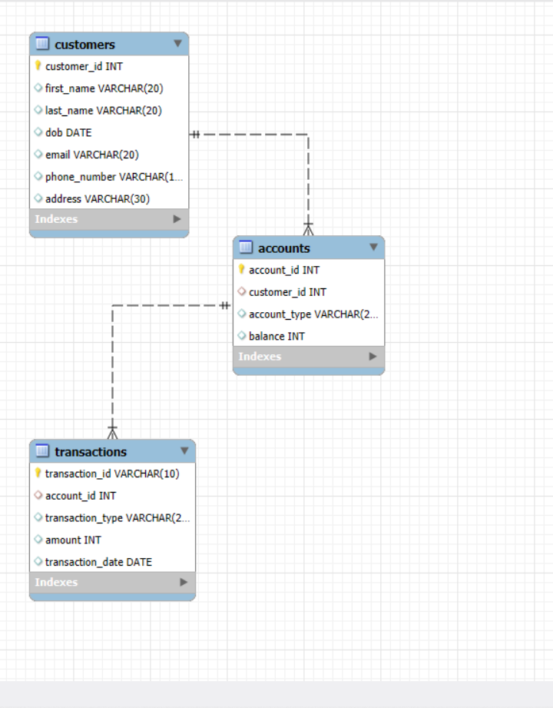

4.Create an ERD (Entity Relationship Diagram) for the database.

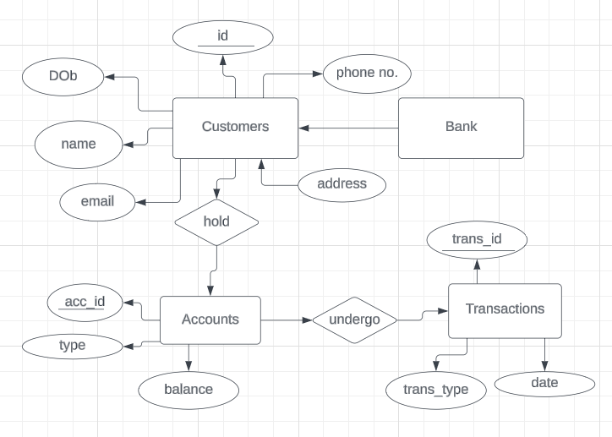

5. Create appropriate Primary Key and Foreign Key constraints for referential integrity.

Customers: Primary key=customer_id

Accounts: Primary key=account_id Foreign key= customer_id

Transactions: Primary key= transaction_id Foreign key= account_id

6. Write SQL scripts to create the mentioned tables with appropriate data types, constraints,

and relationships.

• Customers

• Accounts

• Transactions

**Customer:** create table customers(customer_id integer(5),

first_name varchar(20),

last_name varchar(20),

dob date,

email varchar(20),

phone_number varchar(10),

address varchar(30),

constraint customers_customerId_pk primary key(customer_id));

**Accounts:** create table Accounts(account_id integer(5),

customer_id integer(5),

account_type varchar(20),

balance integer(10),

constraint accounts_accountId_pk primary key(account_id),

constraint customers_customerId_fk foreign key(customer_id) references customers(customer_id));

Transactions: create table transactions(transaction_id varchar(10),

account_id integer(5),

transaction_type varchar(20),

amount integer(10),

transaction_date date,

constraint transactions_transactionId_pk primary key(transaction_id),

constraint transactions_transactionId_fk foreign key(account_id) references accounts(account_id));

**Task 2:** Select, Where, Between, AND, LIKE:

1. Insert at least 10 sample records into each of the following tables.

• Customers

• Accounts

• Transactions

**Customers:**

insert into customers values(101, 'Alice', 'Johnson', '1990-05-14', 'alice@gmail.com', 1234567890,'Utah 89059');

insert into customers values(102, 'Jasmine', 'Lopez', '1994-11-02', 'jasmine@gmail.com', 1234567899,'Michigan 45678');

insert into customers values(103,'Jones','Harrison','1990-02-11','jones@gmail.com', 9763987254,'Washington 98706');

insert into customers values(104, 'Bob', 'Smith', '1985-10-22', 'bob@gmail.com', 2345678901,'Tenesse 90367');

insert into customers values(105, 'Charlie', 'Brown', '1992-03-08', 'charlie@gmail.com', 3456789012,'California 83210');

insert into customers values(106, 'Diana', 'Prince', '1988-12-01', 'diana@gmail.com', 4567890123,'Washington 78560');

insert into customers values(107, 'Ethan', 'Hunt', '1995-07-30', 'ethan@gmail.com', 5678901234,'Boston 84536');

insert into customers values(108, 'Hannah', 'Clark', '1991-09-25', 'hannah@gmail.com', 8901234567,'Oregon 90007');

insert into customers values(109, 'Ian', 'Taylor', '1986-06-14', 'taylor@gmail.com', 9012345678,'Utah 69007');

insert into customers values(110,'Smith','Rye','2000-09-26’, 'smith@gmail.com',

7956432900,'Michigan 45678');

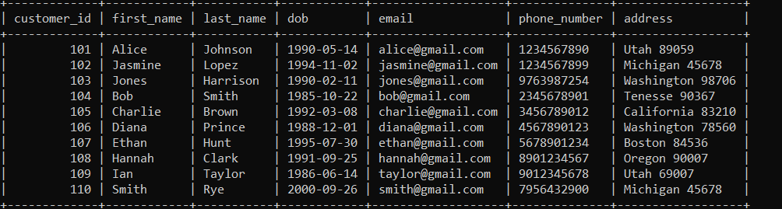

**Accounts:**

insert into Accounts values(1, 101, 'Savings', 15000);

insert into Accounts values(2, 102, 'Current', 25000);

insert into Accounts values(3, 101, 'zero-balance', 5000);

insert into Accounts values(4, 103, 'Savings', 3000);

insert into Accounts values(5, 104, 'zero-balance', 7000);

insert into Accounts values(6, 110, 'Savings', 12000);

insert into Accounts values(7, 106, 'zero-balance', 18000);

insert into Accounts values(8, 107, 'Current', 10000);

insert into Accounts values(9, 105, 'Savings', 4500);

insert into Accounts values(10, 109,'zero-balance', 6000);

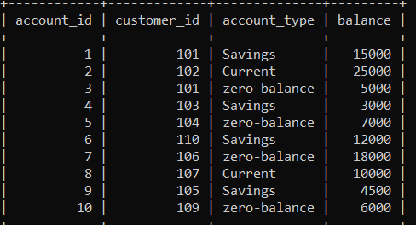

**Transactions:**

insert into transactions values ('A11', 1, 'Deposit', 1000, '2024-01-15');

insert into transactions values ('B12', 2, 'Withdrawal', 5000, '2024-01-16');

insert into transactions values ('C13', 4, 'Transfer', 2000, '2024-01-17');

insert into transactions values('D14', 3, 'Withdrawal', 1500, '2024-01-18');

insert into transactions values ('E15', 6, 'Deposit', 3000, '2024-01-19');

insert into transactions values ('A16', 8, 'Withdrawal', 1000, '2024-01-20');

insert into transactions values ('C17', 5, 'Transfer', 5000, '2024-01-21');

insert into transactions values ('F18', 4, 'Withdrawal', 2500, '2024-01-22');

insert into transactions values ('B19', 9, 'Deposit', 7000, '2024-01-23');

insert into transactions values('D10', 10, 'Transfer', 4000, '2024-01-24');

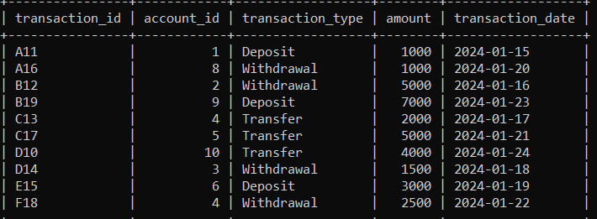

2. Write SQL queries for the following tasks:

1. Write a SQL query to retrieve the name, account type and email of all customers.

Query: select c.first_name, c.last_name, a.account_type, c.email

from customers c inner join accounts a

where c.customer_id=a.customer_id ;

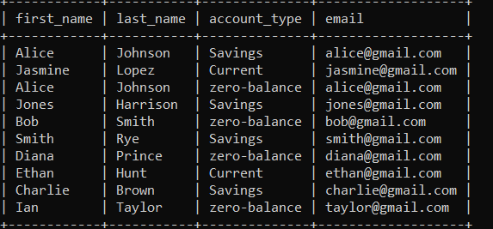

2. Write a SQL query to list all transaction corresponding customer.

Query: select c.first_name, c.last_name, t.transaction_id, t.amount, t.transaction_type

from transactions t inner join accounts a

on t.account_id=a.account_id inner join customers c

on a.customer_id=c.customer_id;

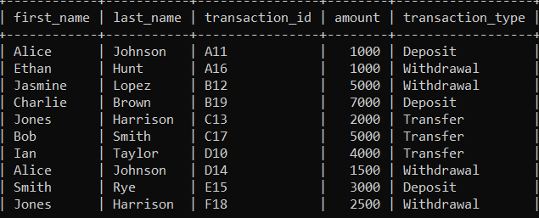

3. Write a SQL query to increase the balance of a specific account by a certain amount.

Query: update accounts set balance=balance+1000 where account_id=1;

4. Write a SQL query to Combine first and last names of customers as a full_name.

Query: select concat(first_name,' ' ,last_name) as full_name from customers;

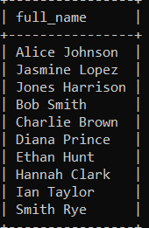

5. Write a SQL query to remove accounts with a balance of zero where the account type is savings.

Query: delete from accounts where balance=0 AND account_type='Savings';

6. Write a SQL query to Find customers living in a specific city.

Query: select * from customers where address LIKE '%Washington%';

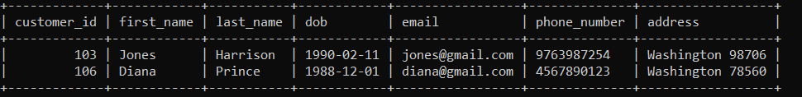

7. Write a SQL query to Get the account balance for a specific account.

Query: select account_id, balance from accounts where account_id=3;

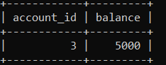

8. Write a SQL query to List all current accounts with a balance greater than $1,000.

Query: select account_id, account_type, balance from accounts where balance>1000 AND account_type='current';

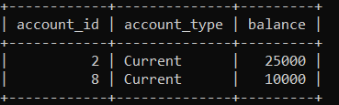

9. Write a SQL query to Retrieve all transactions for a specific account.

Query: select * from transactions where account_id=4;

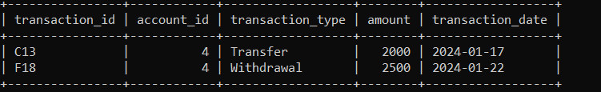

10. Write a SQL query to Calculate the interest accrued on savings accounts based on a given interest rate.

[if interest_rate=0.04]

Query: select account_id, balance, account_type,(balance*(0.04/100)) as interest_accrued from accounts where account_type = ‘Savings’;

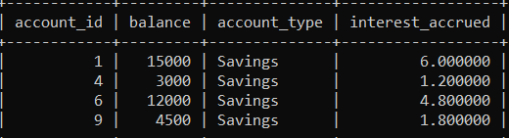

11. Write a SQL query to Identify accounts where the balance is less than a specified overdraft limit.

Query: select account_id, balance from accounts where balance<12000; [overdraft_limit=12000]

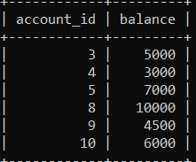

12. Write a SQL query to Find customers not living in a specific city.

Query: select customer_id, first_name, last_name, address from customers where address NOT LIKE '%Michigan%';

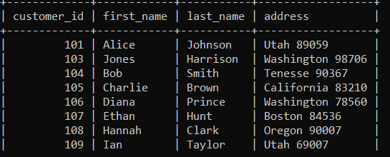

**Tasks 3: Aggregate functions, Having, Order By, Group By and Joins:**

1. Write a SQL query to Find the average account balance for all customers.

Select c.customer_id,avg(balance) as avg_balance from customers c

Inner join accounts a where c.customer_id=a.customer_id

Group by c.customer_id;

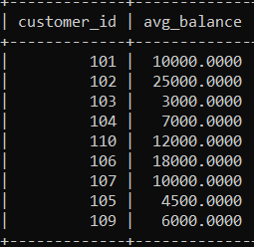

2. Write a SQL query to Retrieve the top 10 highest account balances.

Select balance from accounts order by balance desc;

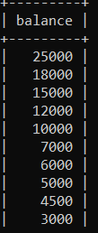

3. Write a SQL query to Calculate Total Deposits for All Customers in specific date.

Select c.customer_id, sum(t.amount) as total_deposits , transaction_date

from transactions t inner join accounts a

On t.account_id=a.account_id inner join customers c

On a.customer_id=c.customer_id group by t.transaction_date, c.customer_id;

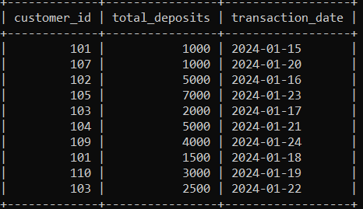

4. Write a SQL query to Find the Oldest and Newest Customers.

Oldest customer:

select * from customers where dob = (select MIN(dob) from customers);



Newest customer:

Select* from customers where dob=(select max(dob) from customers);



5. Write a SQL query to Retrieve transaction details along with the account type.

Select t.transaction_id, t.transaction_type, t.transaction_date, t.amount, a.account_type

From transactions as t inner join accounts a where t.account_id=a.account_id;

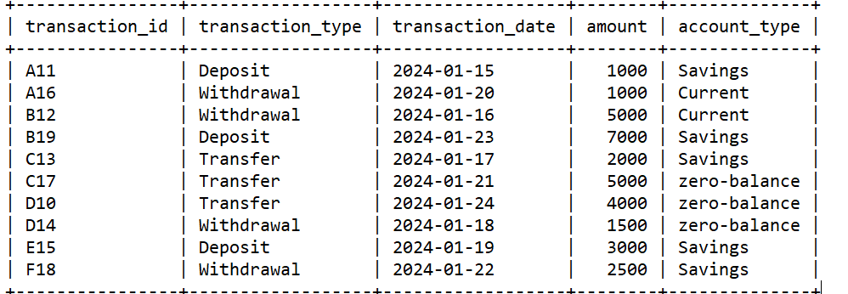

6. Write a SQL query to Get a list of customers along with their account details.

Select c.customer_id, c.first_name, c.last_name, a.account_id, a.account_type, a.balance

from customers c inner join accounts a

where c.customer_id=a.customer_id;

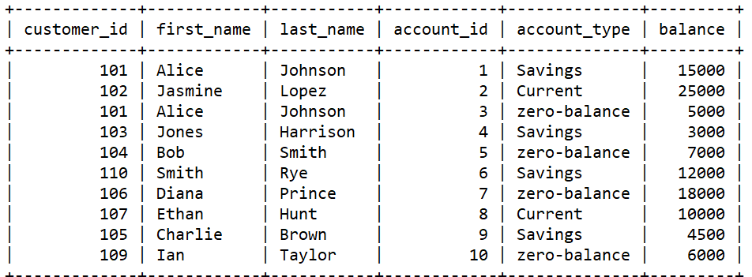

7. Write a SQL query to Retrieve transaction details along with customer information for a

specific account.

Select c.customer_id, t.transaction_type, t.amount , t.transaction_date, t.account_id

from transactions t inner join accounts a

On t.account_id=a.account_id inner join customers c

On a.customer_id=c.customer_id where t.account_id=1;

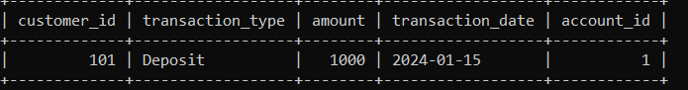

8. Write a SQL query to Identify customers who have more than one account.

Select c.customer_id, c.first_name, c.last_name, count(a.account_id) as total_acc

From customers c inner join accounts a

where c.customer_id=a.customer_id

group by c.customer_id, c.first_name, c.last_name having count(a.account_id) >1;

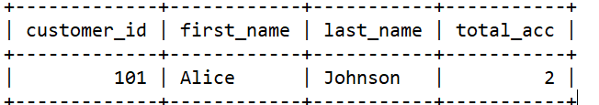

9. Write a SQL query to Calculate the difference in transaction amounts between deposits and withdrawals.

select sum(CASE WHEN transaction_type = 'Deposit' then amount ELSE 0 END) AS total_deposits,

sum(CASE WHEN transaction_type = 'Withdrawal' then amount ELSE 0 END) AS total_withdrawals,

sum(CASE WHEN transaction_type = 'Deposit' then amount ELSE 0 END) -

sum(CASE WHEN transaction_type = 'Withdrawal' then amount ELSE 0 END) as difference

from transactions;

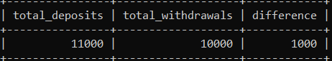

10. Write a SQL query to Calculate the average daily balance for each account over a specified period.

Select a.account_id, avg(a.balance), t.transaction_date

from accounts a inner join transactions t

on t.account_id=a.account_id

group by a.account_id, t.transaction_date

having t.transaction_date between ‘2024-01-15’ and ‘2024-01-23’;

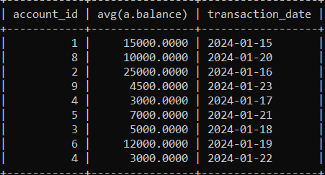

11. Calculate the total balance for each account type.

Select sum(balance) as total_balance, account_type from accounts group by account_type;

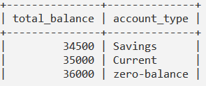

12. Identify accounts with the highest number of transactions order by descending order.

Select account_id, count(transaction_id) as total_transactions

from transactions group by account_id

Order by count(transaction_id) desc;

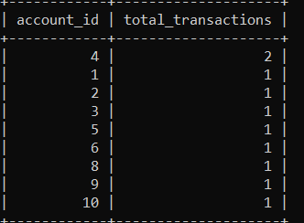

13. List customers with high aggregate account balances, along with their account types.

Select c.customer_id ,sum(balance), a.account_type

from customers c inner join accounts a

where c.customer_id=a.customer_id

group by c.customer_id , a.account_type

order by sum(balance) desc;

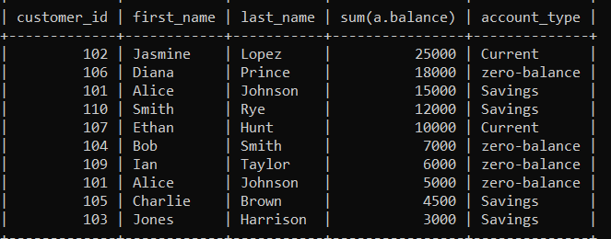

14. Identify and list duplicate transactions based on transaction amount, date, and account.

Select amount, transaction_date, account_id , count(*) from transactions

Group by amount, transaction_date, account_id

Having count(*)>1;



**Tasks 4:**

1. Retrieve the customer(s) with the highest account balance.

Select c.customer_id, c.first_name, c.last_name, a.balance from customers c inner join

accounts a on c.customer_id= a.customer_id

where a.balance=(select max(balance) from accounts);

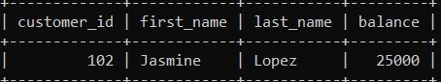

2. Calculate the average account balance for customers who have more than one account.

Select c.customer_id, avg(a.balance) as average from customers c inner join

accounts a on c.customer_id= a.customer_id group by c.customer_id

having count(*)>1;

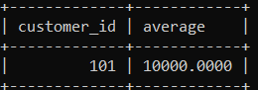

3. Retrieve accounts with transactions whose amounts exceed the average transaction amount.

Select a.*, t.transaction_id, t.amount from transactions t inner join accounts a

On a.account_id=t.account_id where t.amount>(select avg(amount) from transactions);

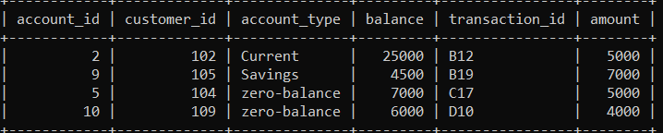

4. Identify customers who have no recorded transactions.

select c.customer_id, c.first_name, c.last_name, c.email

from customers c left join

transactions t ON c.customer_id = t.account_id

where t.transaction_id IS NULL;

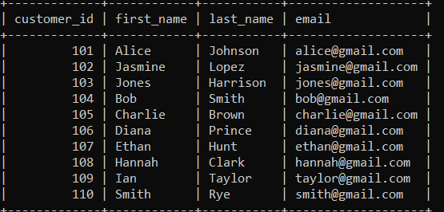

5. Calculate the total balance of accounts with no recorded transactions.

select sum(a.balance) as total_balance_no_transactions

from accounts a left join transactions t on a.account_id = t.account_id

where t.transaction_id IS NULL;

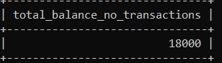

6. Retrieve transactions for accounts with the lowest balance.

Select t.*, a.balance from transactions t inner join accounts a

On a.account_id=t.account_id

Where a.balance=(select min(balance) from accounts);

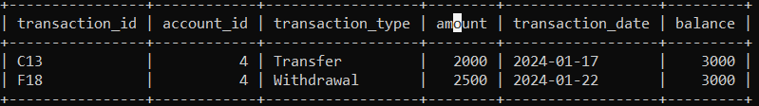

7. Identify customers who have accounts of multiple types.

select c.customer_id, c.first_name, c.last_name,

COUNT(DISTINCT a.account_type) as account_type_count

from customers c join accounts a ON c.customer_id = a.customer_id

group by c.customer_id, c.first_name, c.last_name

HAVING COUNT(DISTINCT a.account_type) > 1;

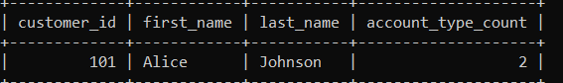

8. Calculate the percentage of each account type out of the total number of accounts.

Select account_type,

COUNT(*) as account_count,

(COUNT(*) * 100.0 / (select COUNT(*) from accounts)) as percentage

From accounts group by account_type;

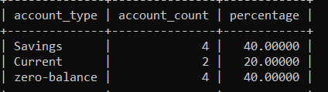

9. Retrieve all transactions for a customer with a given customer_id.

select t.transaction_id, t.account_id, t.transaction_type, t.amount, t.transaction_date

from transactions t

join accounts a ON t.account_id = a.account_id

where a.customer_id = 101;

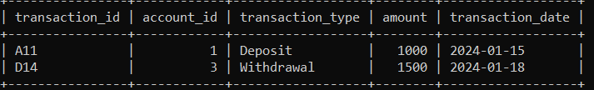

10. Calculate the total balance for each account type, including a subquery within the SELECT clause

select account_type, sum(balance) as total_balance,

(select sum(balance) from accounts where account_type = account_type)

from accounts group by account_type;

